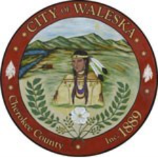
CITY OF WALESKA
Regular Meeting of the Mayor and Council
APRIL 20, 2026

Item 1: Call to Order
Item 2: Invocation / Pledge of Allegiance
Item 3: Five Minute Public Input
Item 4 Consideration to Approve Regular Council Meeting Minutes – April 13, 2026
Item 5: Yard of the Month
Item 6: Farmers Market
Item 7: Audit Services for FY2026–FY2030 – Recommendation and Council Consideration
Item 8: FY26 Mid-Year Budget Amendment Resolution - Amend the FY26 Operating and Capital Budgets
Item 9: Water System Report
Item 10: City Clerk’s Report
Item 11: City Attorney’s Report
Item 12: Mayor’s Report
Item 13: Council Remarks
Item 14: Enter Executive Session – Personnel
Item 15: Adjourn Executive Session
Item 16: Return to Regular Council Meeting
Item 17: Adjournment of Regular Council Meeting

